REQUEST FOR INFORMATION (RFI)

**Subject: Case Law Database**

Date of this RFI: 30 July 2018

Closing date of this RFI: 13 August 2018

Reference Number: ICC RFI 125376

Address RFI for the attention of: Mr. Kazumi Nakamura

E-mail address: [Kazumi.Nakamura@icc-cpi.int](mailto:Kazumi.Nakamura@icc-cpi.int)

1. **INTRODUCTION**:

The purpose of this RFI is to identify potential suppliers and to gather ideas from the market for the provision of new solution for Case Law Database for the International Criminal Court.

This RFI will serve to conduct market research to identify companies offering suitable products. This market research shall be conducted at no cost to the ICC.

This announcement is a Request For Information (RFI), not a solicitation for proposals, and accordingly, no contract will be awarded from this announcement. No reimbursement will be made for any cost associated with providing information in response to this announcement or any follow-up information requests. No telephone calls requesting a solicitation will be accepted or acknowledged. There is no solicitation available at this time. Market responses, as a result of this announcement, shall focus on providing recommendations for the provision of user experience research as detailed in the RFI.

Responses to this RFI should be submitted electronically to the following email address:

[Kazumi.Nakamura@icc-cpi.int](mailto:Kazumi.Nakamura@icc-cpi.int)

Responses are due no later than 17.30 PM CET on 13 August 2018.

The ICC appreciates your assistance with this market research and emphasizes that this effort is for planning purposes only. Responses will not be treated as proposals, but may be used to create any subsequent Request for Proposal (RFP). Information provided in the RFI may be used by the ICC in acquisition documents.

1. **SERVICE DESCRIPTION**

The ICC hereby seeks for information on the provision of new Case Law Database to contain public documents and be accessible to general public over the Internet.

More specific non-exhaustive requirements are provided below.

**Data Structure**

Case Law consists of four different entity types:

* 1. Document entity – a combination of document and associated metadata. At the moment here are two distinct document entity types: Decision (D) and Legal Finding (LF). Besides different metadata fields associated with each entity types, LF does not have actual documents, but metadata only (although metadata for LF includes free text field that could contain several paragraphs of text).
* Decision  – can refer to any judgment, decision, order, warrant, summons, or any other similar type of document issued by any ICC Chamber or the Presidency
* Legal Finding  – are verbatim jurisprudential text from a decision
  1. Link entity – a relationship connecting two entities and metadata fields describing the relationship
  2. Keyword hierarchy – a tree of keyword terms
  3. Simple link – a possibility to associate keyword at different hierarchy level with document entity, no metadata is recorded on the link itself.

**Functionality**

1. Ability to create different entities and link them.
2. Ability to upload documents, associated metadata and links in batches or one at a time.
3. Full text search over the document metadata and content of entities
4. Ability to create searches including: metadata and full text searches
5. Ability to create searches combining criteria related to more than one entity. For example, query on the entity pair “Decision-Legal Finding” where certain criteria would apply to metadata associated with all three: D, LF and the relationship, plus full text search criteria for “Decision”  is fulfilled.
6. The system should be bi-lingual, English-French. If possible, ability to do automatic translation of legal findings text and metadata
7. Ability to navigate contents from different perspectives: document, Link or keyword entity.
8. Ability to adjust presentation to showing Decision Entity – with all associated Legal Findings (multiple) on one screen.

Case Law Entity model is provided on the diagram below.

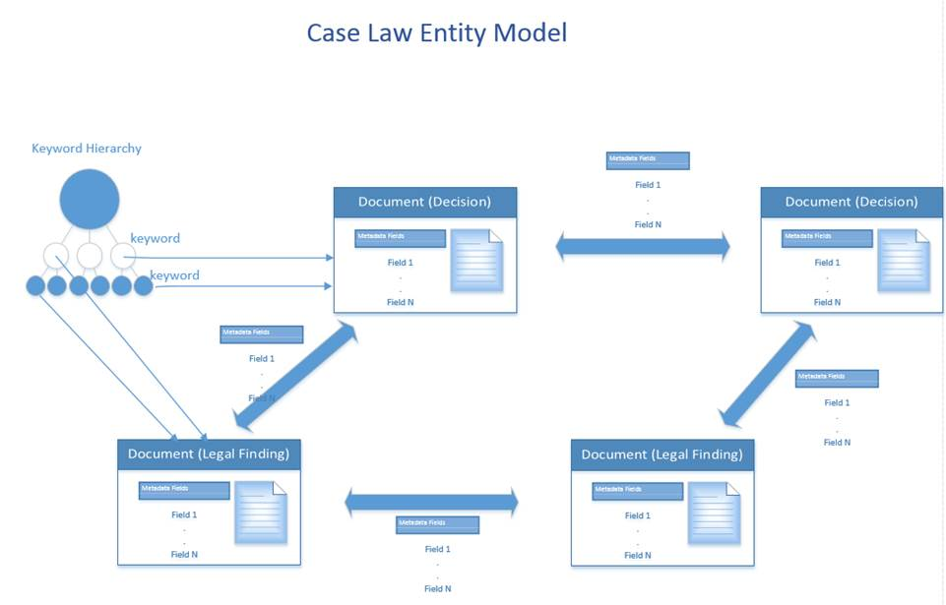

**3) DOCUMENTATION TO BE SUBMITTED**

Interested suppliers shall include the following set of documentation in their responses to this Request for Information:

1. A brief profile of the company including size, location, areas of expertise for providing ECM solutions;
2. Detailed description of the solution offered, clearly indicating the match to the functionality mentioned in the section 2 of this document;
3. Reference to similar projects with client references;
4. Any additional information that will help ICC understand more about your product;
5. **Indicative** product pricing;
6. Complete contact details of the persons to whom any further correspondence must be sent, including name, position, email address and phone number.

The response to the request for information should specify the ICC’s reference number **ICC RFI 125376** and shall be received no later than 17.30 hrs, The Hague local time on 13 August 2018.

The ICC intends to use the outcome of this RFI to inform any possible upcoming procurement request to meet requirements in the above specified areas of need. Interested suppliers should forward their documentation per email (max. 4 MB per email message with no limits on number of messages), to the following address:

[Kazumi.Nakamura@icc-cpi.int](mailto:Kazumi.Nakamura@icc-cpi.int)

Please note that no further details of the planned solicitation can be made available to the vendors prior to issuance of the solicitation documents / subsequent Request for Proposal (RFP).