ICC website Court Records management system
The main purpose of this draft paper is to describe the Court Records Management system of the new ICC website.
The new ICC website will need to have an Automatic Court Records management system for uploading the court records and adding related metadata. The system and its logic will be used for other types of data as well (statements, publications, AV materials, photographs).

Basic Technical Requirements
The basic technical requirements are as follows:
1. Content type – Court record with the following columns:
Original Title Multiple lines of text (Original Title)
Main Document Number Single line of text (Original document number)
Full Document Number Single line of text (The current document number)
Document Reference Single line of text (Parent document number)
SeqNo Single line of text (Sequence number for the sorting order)
Situation Code Single line of text (Situation number)
Situation Name ENG Single line of text (English)
Situation Name FRA Single line of text (French)
Case Code Single line of text (Case number)
Case Name ENG Single line of text (English)
Case Name FRA Single line of text (French)
Date Of Document Single line of text (Original date of the submission)
Document Type ENG Single line of text (Legal type of the document (Decision…))
Document Type FRA Single line of text (Same as above but in French)
Date Received Single line of text (Publishing date of the document)
Interlocutory Appeal Single line of text (The IA number)
Language Single line of text
Phase of Case ENG Single line of text
Phase of Case FRA Single line of text
Source ENG Single line of text
Source Fra Single line of text
Type of Hearing ENG Single line of text
Type of Hearing FRA Single line of text
Name Single line of text (Name of the file – very important)
Original Single line of text (y or n)
RType Single line of text (Annex, corrigenda …)
RelatedDoc Single line of text (TRIM number – important for linking the
other related documents)

2. Two site collections
Two site collections are necessary in order to separate the content load from the content delivery. The content load site collection will contain all the data in specific catalogs. The content delivery site collection will contain the front facing (public) website which will be available to the audience. All continuously added content will be delivered in this manner.
3. Records center
A records center is needed to have one central place for uploading court records. The records will then be routed to an appropriate location based on the Case code metadata column.
4. Workflows
Workflows need to be created for:
- Updating metadata of the court new court records
- Updating metadata for the current documents inside catalogs
- Triggering indexing of the newly updated files
5. Web parts
We need to create minimum number of web parts and make them as reusable as possible in order to simplify the technical structure of the website and to increase the productivity of the same. Web parts will need to have specific entries which will govern the usage and behavior.
6. Display templates
Display templates will have to be created to govern the look and amount of data displayed per result in the search engine and court records index pages. There will be two versions: one for case level and one for global level. The case level display templates will be used to show the results of the Content-by-search web part inside the case sub site, while the global one will be used for the results of the search engine and content-by-search web parts on the home page and other locations which will pull data from multiple catalogs.
7. Template page
A template page needs to be developed in order to show individual court record entry. All data will be automatically displayed based on the metadata related to the individual document. The page will feature multiple instances of content-by-search web part (one to display metadata of the case, one for the immediately related documents (annexes, corrigenda) and one for other related documents (following RelatedDoc metadata column)).

System described

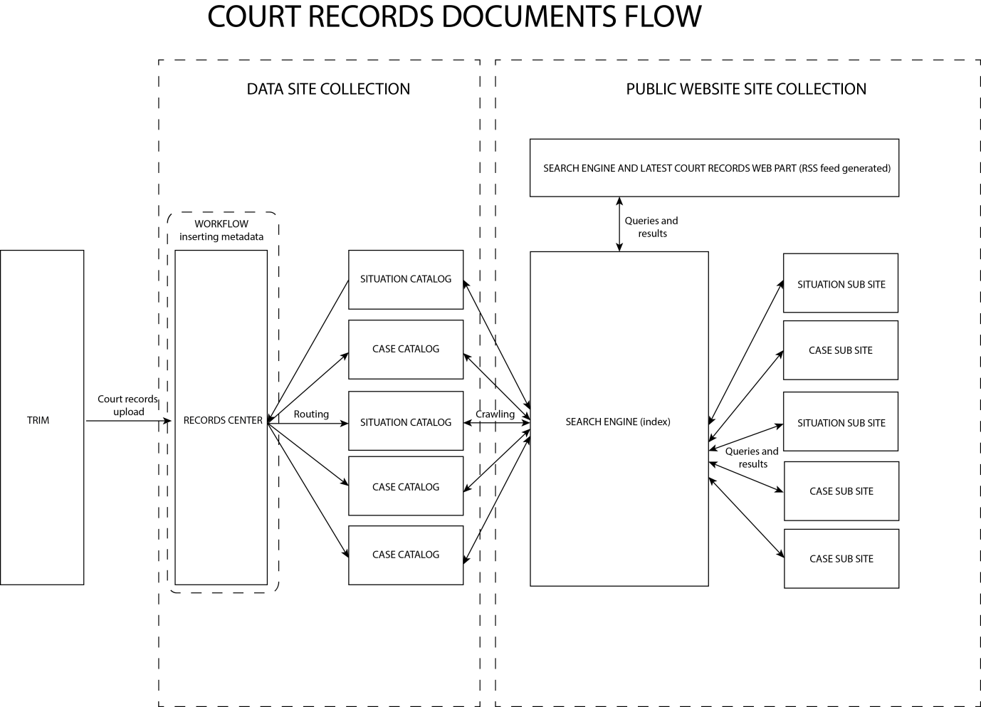
System is content driven. Metadata attached to the files are used to drive the court records section of the website and display templates are used to present the items (court records).

System setup:
- Separate site collection for data only
- Records Center
- Catalog libraries
- Cases sub-sites of the “Public” site collection are connected to the catalogs
- Content by search web part is used to show the court records.
- Refiners are used to filter/sort records by Source.
- Display template is created to be used by the web part
- A template page is created for Court records which will run web parts in order to show all related documents (main document (translations), annexes and corrigenda (links to the individual documents showing titles and document number) and related documents (also titles and document numbers).

Metadata coming from TRIM:
Title
Case Code
Case name/situation name (container)
Document Type
SeqNo
Source
Main Document Number (Original document number)
Full Document Number (The current document number)
Document Reference (Parent document number)
Original (y or n)
RType
RelatedDoc
Phase of Case
Language
Date of Document
Type of Hearing
Interlocutory Appeal

Metadata workflow

Basic requirements
Required lists:
- Situations and cases (all situations and cases and their versions)
- Documents types
- Phase of the case
- Language
- Type of hearing
- Source

Situations and cases
The list will need to contain:
- All names of situations in English and French
- All names from the original TRIM container
- All cases in English and French and possible versions
- Cases numbers
- Situations numbers
Every entry made from TRIM container field will be matched with an appropriate value in the English and French column and the case/situation number.

Document types
The list needs to contain:
- All possible entries from the TRIM Document type field
- All possible entries from the ICC Taxonomy related to the field above in English and French
Every entry made from TRIM Document type field will be matched with an appropriate value in English and French.

Phase of the case
The list needs to contain:
- All possible entries from the TRIM Phase of Case field
- All possible entries from the ICC Taxonomy related to the field above in English and French
Every entry made from TRIM Phase of case field will be matched with an appropriate value in English and French.

Language
The list needs to contain:
- All possible entries from TRIM Language field
- All possible Entries from the ICC Taxonomy related to the field above
Every entry made from TRIM Language field will be matched with an appropriate value from the ICC Taxonomy.

Type of hearing
The list needs to contain:
- All possible entries from TRIM Type of hearing field
- All possible entries from ICC Taxonomy related to the field above
Every entry made from TRIM Type of hearing field will be matched with an appropriate value from the ICC Taxonomy in English and French.

Source
The list needs to contain:
- All possible entries from TRIM Source field
- All possible entries from ICC Taxonomy related to the field above in English and French
Every entry made from TRIM Source field will be matched with an appropriate value from the ICC Taxonomy in English and French.

Workflow
The workflow will be triggered upon arrival to the Records Center. The workflow can also be triggered manually by the administrator. It will fill the following metadata fields utilizing the above mentioned lists:
- Situation Name ENG Single line of text
- Situation Name FRA Single line of text
- Case Name ENG Single line of text
- Case Name FRA Single line of text
- Document Type ENG Single line of text
- Document Type FRA Single line of text
- Language Single line of text
- Phase of Case ENG Single line of text
- Phase of Case FRA Single line of text
- Source ENG Single line of text
- Source Fra Single line of text
- Type of Hearing ENG Single line of text
- Type of Hearing FRA Single line of text

If the workflow came back with false as the result, an email is sent to administrators (Public Affairs Unit (two members of the unit)) with the error message. The document is skipped and the next document is then being worked on.
Example:
A new case is officially declared. A court record is automatically sent to the Record center. There is no structure made for this file. The document is left in the drop-off library in the Record center, email is sent to the administrator and he/she will then first create the appropriate catalog, metadata entries and then manually trigger the workflow for the above mentioned document. The document is then routed to the newly created catalog. The administrator will then create the appropriate connections and trigger the full indexing of the catalog in order to make the records available on the public facing site collection.
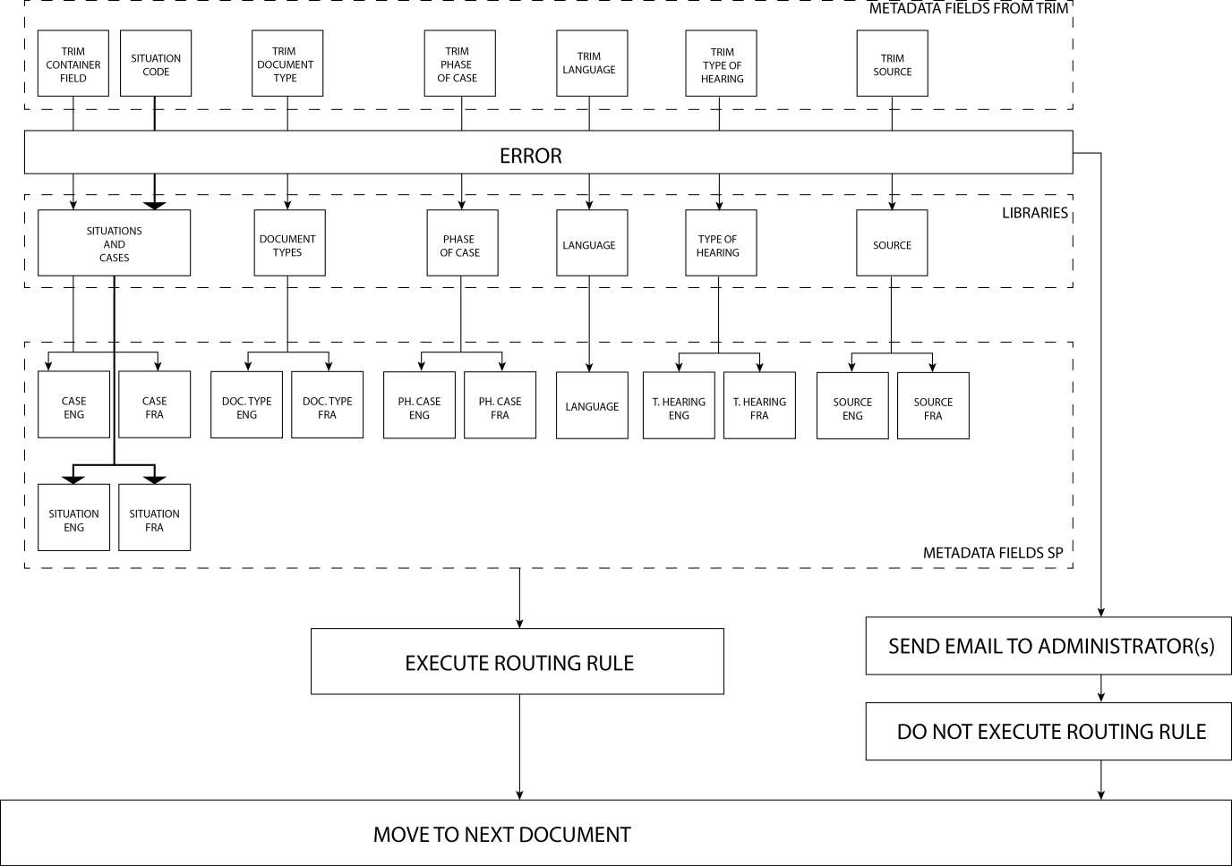

System working
- Document is sent from TRIM.
- The document is named as a TRIM record number (CRyear/number) where “/” is substituted with “_”.
Example:
Original TRIM number: CE2014/150
Court Record file name: CR2014_150.pdf
- Document is uploaded to the ICC website Records Center.
- Workflow is triggered automatically upon arrival of the court record and metadata fields are populated with correct data
- Case code metadata column is used to route the document to an appropriate catalog
- An email is sent to administrator informing of a court record being placed in the catalog.
- The court record is checked and approved.
- The court record is indexed by the search engine.
- The court records index page is showing the court record in the list.

The court records index web part
This will be a content-by-search web part with the customized display template showing court records with the following fields displayed in respected languages:
- Date received
- Full Document Number (the translation will be shown in the respected language site)
- Original Title
- Source
- Document Type
- Case Name (a colloquial case name will be used)
- Including (this needs to show if the document does include Annexes, Corrigenda, Dissenting and/or Separate opinions) - !important – a solution need to be created for this column.
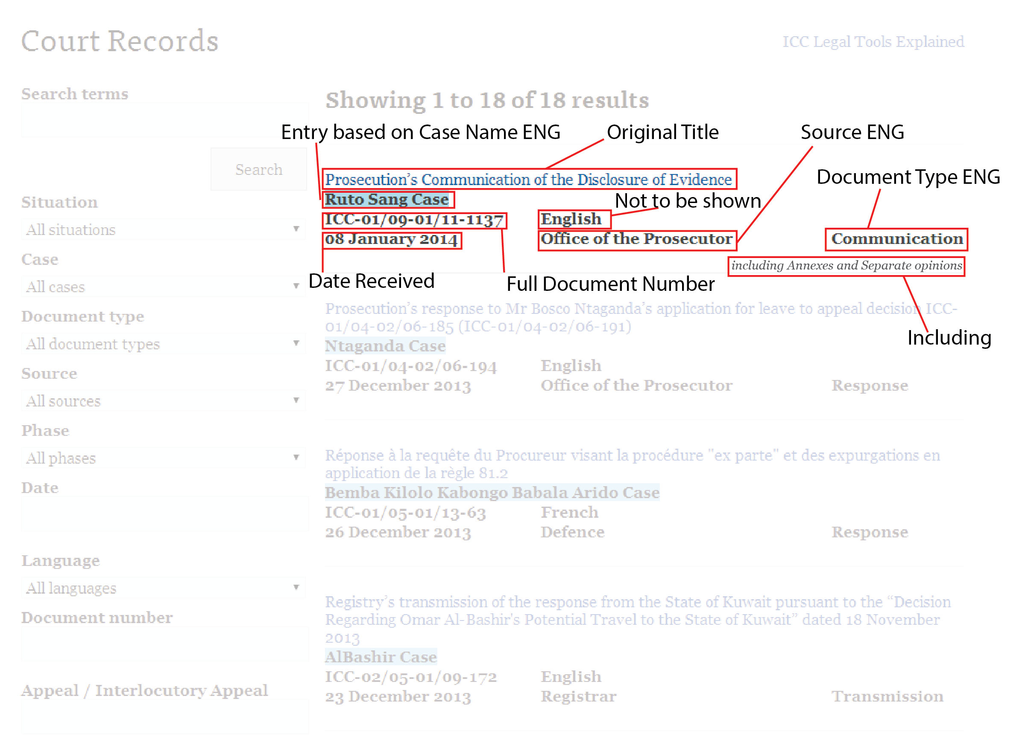

Rules:
- Always show the language of the current site if the court record in that language is available. If not show the original language. Example: A court record is only available in French. On the English site, the CR index web part shows the French document. As soon as the translation in English is available, the translation is shown.
- An original document always has a priority over redacted ones and their corrigenda.
- Corrigendum of a document has a priority over an original document. This means that the index web part will show corrigendum rather than it’s original. Example: A redacted version of the document has a corrigendum (ICC-01/04-02/06-194-Red-Corr). This document is then shown on all index web parts. However, if an original (non-redacted) document is disclosed later, it will be shown instead of the corrigendum one, so in this example ICC-01/04-02/06-194 is to be shown).
- If a document has multiple redactions (-red; -red3; -red3…) the document with the higher number is shown.
- Annexes are not shown.
- Only one entry per Document Reference can be shown.
There also will be a filtering rule. This is necessary to show documents based on specific criteria like:
Display all court records from [specific catalog] where sequence number is between specific ranges.
The CR index web part (customized content-by-search web part) need to be very flexible. All the rules need to be introduced by administrator by the usage of specific fields. This way we will be able to introduce new rules for the court records.
Problem:
The case has split into two cases, where one case remains as a successor of the previous case, using the same Case code, while the other case is given the new Case code. The real problem starts with the records for the second case, as all the relevant court records from the first case need to be featured in the second case. The possible solution: The second site is connected to two catalogs. The catalog containing the old case’s court records and the new catalog containing the new court records. A rule need needs to be created where the index web part would show all records from the old catalog following a specific Sequence number range (from 15-3005) and all the records from the new catalog. The second problem is the order of the documents in this case. This would be solved by the workflow for the new catalog, where a new base number would be created. Example:
The old case records go up to number 3300. Since the order is based on the sequence number, the new catalog would then have a workflow which would then add a base number (4000) to every new record in this catalog, so the record with the sequence number 1 would become 4001. With this, all court records would then be ordered correctly.

The court record itself
- Template page is used to display the following:
  - Metadata of the main document
  - Download links of the main document; original and translations
  - Related annexes if exists
  - Related documents from the case
- Problem:
  - Only annexes are released
- Solution:
  - PIDS administrator is informed of that by the catalog
  - An empty document is created to serve as the main document until the main document is released (this needs to be done manually by PIDS)

Template Page
Rules:
- Every document is represented via court records page template
- All immediately related documents (annexes, corrigenda…) are a related by the Document Reference metadata field.
- The other related documents are filtered by “RelatedDoc” metadata field (TRIM Record number)
- Court records page template is always used to show the document (like a page) before the PDF is downloaded
- Page template will show metadata of the document in the respected language (English for English site and French for French site). – If the document is not translated yet, then the original document is shown, otherwise, the translation is shown.
- Page template will only show translations of the selected (active) document, so if an original document is selected, download links will appear only for that document, while related documents (annexes, corrigenda other documents) will be displayed as titles with links.
- Display template features the selected metadata and three web parts (one for translations, one for annexes and one for related documents) – this will be a single web part.

URL of a single document
The URL should be formed following the logic:
Curent position/Source/Name
Example:
Document: ICC-01/05-58-Red2
URL: www.icc-cpi.int/en/car/records/office-of-the-prosecutor/CR2014_01786
Document: ICC-01/04-01/06-2063-tFRA
URL: www.icc-cpi.int/fr/drc/lubanga/records/trial-chamber-I/CR2014_01742
This is the only way to ensure that every document has its own unique path.

Web parts

Links to the PDFs of the current document and its translations
Using “Full Document Number” and all of its permutations (-t…) generate direct links to the PDFs. The text in the link is equal to “Language” metadata field.
Example: The document ICC-01/04-01/06-2063 would have the following siblings:
ICC-01/04-01/06-2063 (original)-English document
ICC-01/04-01/06-2063-tFRA (translation)-French
The document links would be represented as:
Download
Original document (English) | Translation(s): Français

Links to the directly related documents
- Check the language first (url-language selector)
- Based on language, display related documents in the appropriate language
- If the language is not available show the next one (so if English is missing, show French)
- Display: “Main Document Number” – “Original Title”.

Structure of the page
The page will be formed out of the following metadata and logic (the text in bold is the hard coded text on the page and entries in italics are metadata entries):
--Original Title--
--Full Document Number --
--Date Received-- | --Source (Language)-- | --Document Type (language)--
Case: --Case Name (Language)--
Situation: --Situation Name(Language)--
Filed during -- Phase of Case—phase
Download
Original document (note: based on the --Original--) --Language-- | Translation(s): --Language—
Related documents (shows the language of the site (English titles for the English site and French titles for the French site / if the appropriate language does not exist yet, shows the available one)
-- Main Document Number-- - -- Original Title—
Other related documents (based on – RelatedDoc--)
-- Main Document Number-- - -- Original Title--
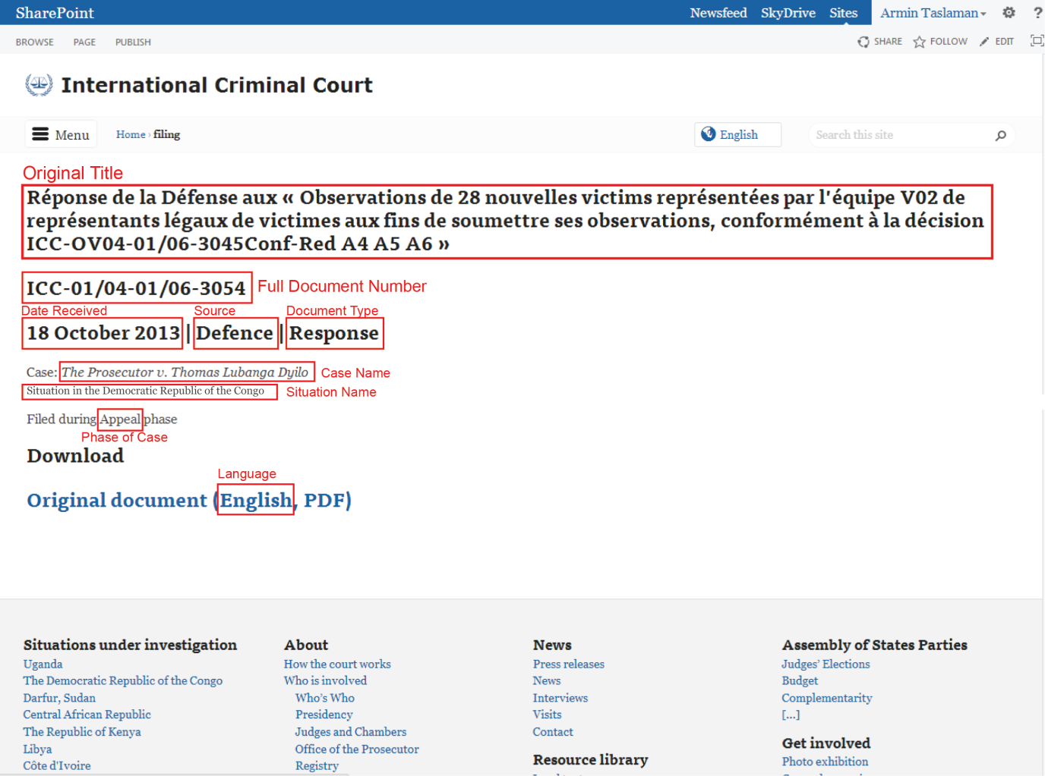

Other Related documents
Other related documents will be shown based on the entries in the RelatedDoc column. We need to find a suitable solution for this, as this information changes with new court records being produced. Possible solution would be to have a secondary workflow for updating RelatedDoc entries in the already existing document in the catalog.
Example:
A new response by a party is created after an order of the Chamber asked for submissions of all parties. The Record Center’s workflow sorts all metadata and the document is routed to a new catalog. After being placed in the catalog, a new workflow is triggered to check if RelatedDoc field is empty. If empty, the workflow is stopped and the file is left alone. If the field is not empty, then, the workflow identify all the records affected by the document, and update their RelatedDoc fields to contain the new document name. After the workflow is completed, an index is performed to all updated documents.
Document number: ICC-01/04-01/06-2063
Name of the file: CR2014_01742
RelatedDoc: CR2014_01718, CR2014_01118, CR2014_00038, CR2014_00001
Workflow:
Add the value “CR2014_01742” to RelatedDoc of the following documents: CR2014_01718, CR2014_01118, CR2014_00038, CR2014_00001
Index: CR2014_01718, CR2014_01118, CR2014_00038, CR2014_00001, CR2014_01742

Long term solutions
We need to plan for the following issues:

1. Situation and Case retirement
There should be a policy about the time limit for the documents retention on the active server.
Solution 1
Separate site collection would be created for historical purposes to store all the closed cases and closed situations after a period of 7 years (this is an ICC wide document retention policy).
The separate site collection would be outside the range of the website search engine. The historical site collection will be fully searchable. Once the case/situation is migrated to the historical site, there would be no more documents addition. The backup would be triggered manually and once every 6 months.
The manual backup would be done every time a new situation/case is migrated. After that the backups would be done once every 6 months.
There would be a link to the historical site collection from the ICC main website.
Solution 2
An offline site would be created. The site would be accessible only from within the Library and Research Centre. The site would reside on the ICC Intranet and would have the same backup setup as above.
There would be a specific section of the website created to promote and explain the historical site. The section would feature the request form to visit the site.

